**1.Product description**

**1.1 Introduction**

We live in a society where innovation is the daily bread. Where not evolving fast enough means being stuck and being forgotten by the public in just a few months. It is a hipster society, critical, that gets bored fast and wants to be up to date with absolutely everything in just one click.

But it's not just that, our society itself is a contradiction. It wants to be part of a group but stand out within it. It wants to be different but not enough to be weird. It wants to have it all but in a simple way. What our society is looking for is the definitive tool to cover everything. At your fingertips. Now. And, that is so simple to use that it does not require any effort.

This is where mobile phones come into action. They are part of everyday life. They sleep, eat and work with us. They bring us closer to the people around us and have enough capacity to store our entire lives in their processors. That said, it seems logical that these devices begin to be increasingly involved in other processes we do every day. Due to this trend, technologies such as the NFC have gained strength over others. Transferring data is as simple as being near to your receiver. Paying using only the mobile phone is no longer a fantasy.

And there are many more possibilities to explore.

**1.2 NFC technology**

Near Field Communication allows data transfer between devices. Those devices only need the required chips for such connection. Fortunately, most of the gadgets we daily come across with have them already. And, if they don´t, depending on the purpose we need them for, they can be incorporated very easily.

NFC works using radio frequencies as Wifi and Bluetooth do. But, there are some main differences between such technologies.

Firstly, it works with low-speed waves. This means that the amount of information that can be transfer per second is relatively low. And, second, this type of communication has a very small range. In order to establish a channel between two devices they have to be very close to each other or even, sometimes, some contact is needed. However, no password or pairing is necessary, which makes creating a connection a very fast process.

This may look as a huge disadvantage in comparison to other communication methods but, here is where the security of the NFC lies. In order for a hacker to obtain any kind of information from our device, he/she would have to be too close, to much for us not to notice. Moreover, since the range is so limited, the NFC chip have to be placed in certain position with respect to the receptor. Making it even more difficult to steal any data. And, in the case of phones, the NFC chips that they have are referred to as Active. So, they do not send any type of information to other devices without explicitly activating the communication option.

Basically, the NFC technology aims to make small transfers of information in a simple and fast way without having to make a previous registration of the devices with which we want to connect.

**1.3 App description**

The concept of loyalty card has extended a lot, since, it aims to reward regular customers and get sales thanks to exclusive offers or promotions. All these cards exist physically and sometimes, the client is required to carry them in order to be able to benefit from their use. But this is not the only type of card that an average person has to carry. Identification cards are mostly absolutely mandatory for legal reasons. And, in case of having some type of private insurance, the physical cards that are given to the clients, ensure that they can make use of that insurance in case of an accident. Finally, there are cards for public transport that obviously cannot be dispensed with if we want to move from one place to another. Which leads us to the conclusion that we have to carry hundreds of cards or give up on some benefits to avoid carrying all of them.

Thanks to new technologies, part of these cards can be carried digitally on mobile phones. Which means that not only wallets will be filled with identifying plastics but also our devices will be full of single function apps, wasting our storage. So, it clearly does not solve the problem.

With the NexuSpace app, we want to offer a solution to all those people who are in this situation. Our idea is to change all physical plastic cards for virtual cards with the same functionality. And we want to use the NFC technology explained above to make it possible.

The users of the app will be able to add the cards they have and group them by folders depending on the field they belong to: official identification, memberships, bank cards … Once added, users can check their status within the application quickly and easily. In case they want to find more specific information, the application will redirect them to the official website of the specific card. And, if a user wants to use them as physical cards, they will only have to be selected them from the folders and the information will be transfer using NFC.

The other side of our application is designed for the companies to which we will offer our service. Since, our final purpose will be to act as a communication channel between companies and customers. In this part, we will offer companies the possibility of managing and obtaining the necessary information about what reaches their consumers through our interface.

In addition, the application will be available not only for mobile phones but also for smart watches.

**1.4 Important features**

Among all the possibilities in our app we want to highlight certain agreements that we plan to achieve in order to offer something unique to our users.

* *Official ID card* : As our app plans to start its activity in Spain, we will use that identity document as an example. Using the source code shared by the national police to bring the use of the NFC to the "DNI"; we want to take advantage of the moment and offer a service similar to the electronic "DNI" but more complete and interactive.
* *Public transport card*: This is one of the key points where NFC technology is used. It can also be recharged directly from the application using the associated bank cards.
* *Access cards*: Another important NFC use. For example, our application could be used to track the employees of a company (clock in when workers arrive or leave the place) or replace passes for specific events.
* Also we would like to remark the fact that not only multinational and well-known brands can add their loyalty cards to our app. In future updates, some specific tools will be added so that small businesses can be included into out interface.

**2. Sector analysis**

**2.1 Generic environment**

- Political-legal factors: The political-legal factors are not a big deal as we are a bridge between companies and users. However, there may be future limitations regarding the digitalization of documents due to the data protection law, which could affect the extended use of our technology.

- Economic factors: Devices with NFC technology are becoming a market standard (according to the 2018 NFC forum study), being essential for electronic trade, so we can say that we will remain in the economy for a very long time for sure.

- Socio-cultural factors: Probably the main issue about our project is the fact that not everyone would be comfortable about having all their identity on a mobile phone, mainly because of the security problems that this could entail or just because of skepticism with respect to the use of the phone for paying. We will have to make the people who will use our application develop confidence in our security system. Nevertheless, The Mastercard Digital Payments Barometer states that more than 30% of Spaniards pay from their mobile phone regularly, which are good news for our company, as we pretend to start our project in Spain.

- Technological factors: Not a huge barrier for our project, because we don’t need an advanced technology to carry out the project, in fact, the required tech was already created. But we do need some experts to develop the product.

**2.2 Specific environment**

- Threat of entry: There is basically no threat of entry because we will be the first ones to offer that exact product, and the risk of another company trying to imitate the same product is very low, and in case it happens, it would be a slow process that would allow us to improve and maintain leadership in the sector.

- Substitute Competition: There are already other paying apps (like Apple Pay or Samsung Pay) that have a similar functionality to our product, because they also allow you to pay with your phone, which is linked to a bank account. But, as our product consists of a more complex and complete form of identity, being linked even to your ID card and public transport card, we can say that there are no substitutes to the product we are offering besides carrying all physical cards with us.

- Supplier Power: The supplier’s power is really low, because we can get the inputs of production from thousands of companies (as they are not so exclusive). So, if our provider raises prices or lowers quality that wouldn’t affect our business because we can get it from another source.

- Buyer Power: The buyer’s power is not so high either. Companies (which are our buyers) can demand better quality and maintenance in our application, but they wouldn’t put so much pressure on our company because we would be saving them a lot of money in terms of the production of physical cards.

**3. Company definition**

**3.1 Legal form**

We, as a company, do not offer a perishable product, but a service that we hope will last for a long time. Especially since, from our vision, it improves the day-to-day life of our users. Therefore, we want to ensure in some way that this service is maintained. We do not want what we have created to be too affected by the administrative decisions we make in the future. We need our brand to have permanence. The best way to make it, at the legal level, is to allow the ownership of the company to be easily transferred. So, in case some of our initial members do not stay in the project, our application can continue in the market without further problem.

In addition, the development of our project requires a complex structure divided into different departments These are the main reasons why we decided that the most suitable legal form for our project is the corporation.

**3.2 Target**

Our target are companies that distribute physical cards and thus their customers identify themselves so that they can use certain discounts and promotions. We also target official documentation distributors to simplify the identification process and make some mandatory legal processes faster. Banks are also very important in our app because is the most widespread use among people.

With respect to the type of user we expect: we target people in the age range of 16-40, people who make continuous use of their phone and who want transactions to be quick and easy.

**3.3 Corporate and competitive strategy**

**3.3.1 Competitive strategy**

Our strategy will be based in differentiation advantage but also in cost advantage. Since, we offer a ramification of a widespread existing product including unique functionalities. We will take advantage of the economies of scale and product design. The differentiation will focus on the tangible differentiation, mainly because of the of complementary services and performance.

**3.3.2 Corporate strategy**

With our app we follow a coring strategy since we are creating a new platform that did not exist. But, part of it is based in a tipping strategy because, with respect to bank cards, the market is quite extensive and spreaded.

In terms of diversification we plan to expand towards related products as, for example, a broader service for companies that want to be part of our interface. Also, we would like to diversify with respect to geography. Our final goal is to is to take our application to all countries of the world. So, once we settle in Spain we will begin to expand our services throughout Europe.

**4. Production system.**

**4.1 production system:**

**4.1.1 production process:**

In order to produce the output we need to have a high technological data center and a well formed programs that will constantly update the platform and corrects errors, the production is focus on employees that will make use of technology to create the software, therefore we need to focus on providing good tools and research environment to the development teams.

We will have to build a big data center as a headquarter and require all the tools needed have it fully operational, for that we will need: servers, internet and phone providers, security, cleaning, computers, furniture and others.

**4.1.2 Production system**

NexuSpace will have a flexible production system, with high qualified workers that have a big responsibility in the production. Special equipment and tools for the developers are required in order for developers to create a good app and service.

This type of production will benefit a lot our company because we can constantly improve and find better ways to operate, the goal is to have a running app that will attract customers by itself, as well to improve from time to time with updated and new features.

**4.2 Cost analysis of the production system**

**4.2.1 Costs associated with the activity (fixed and variable costs.)**

The Fixed Cost for the company to operate would be of 2.225.000 € while the variable cost per product (in this case it would be variable cost per user) is 0,21€/user

**4.2.2 Break- even point calculation**

The breakeven point, having a price of 0,94€/user, and the costs mentioned before would be of 3.047.945 users.

**4.2.3 Ebit and operating leverage. (First year)**

The EBIT acquired in the first year of operations will be -3.875.000€, to see why this results go to part 6.4. The Operating Leverage, with the expected number of users of the first year (500.000 users), is a factor of 20. Based on this calculations we can see that, if there is a big increment in users there will an enormous increment in the profitability, as well as the other way around, these means that the company has a very high risk for investors and shareholders in the initial years because we will be operating way below the break even point and there are both high fixed cost and variable cost that will generally bring more financial risk.

**5. Marketing Plan**

**5.1 Strategic Marketing**

**5.1.1 SWOT analysis**

*5.1.1.1 Strengths:*

-Massive customer appeals: this product solve a big need that appeals to everyone since carrying your ID’s and documents is very important .

-Efficiency in distribution and data management: very quick setup for customers and companies to use our platform, secure treatment of customer data in the cloud.

-Guarantee profits by digitizing your Id’s: for customers this will result in rewards for using the platform as well as a lot of advantages for the daily life. For companies this will save them the cost for producing physical cards and make it easier for the customer to use their product.

-High technological advantages: we take advantage from the current technologies of NFC standards and develop the most advance digital card for the customers with secure management made by experts in our team.

*5.1.1.2 Weaknesses:*

-Long term profitability: since this service is free for customers we relay on a big network effect in order to gain a big profit from the companies.

-High Start up cost and constant expansion: the price for building the app, setting the data centers and maintaining the infrastructure is high. Database will keep expanding each day meaning that we will have to keep expanding servers an employee's.

-No previous reputation: since this is a new company we will have to close the gap of trust from customers by making the app free and guaranteeing profit for companies in order to get more companies to partner, still we can see the big groth that can be made if this happens.

*5.1.1.3 Opportunities:*

-Customers loyalty: this app has the potential to be and everyday use for every customer and make it very hard for them to switch to another company because of all the advantages.

- High growing of the market: NFC is massively expanding worldwide and is growing really fast, make this kind of app necessary for everyone and leaving behind physical cards.

-First mover: the market has been focusing only in payment apps, but we can make a huge impact and include everything you can have in your wallet only in one app, therefore we can make a really big network effect.

*5.1.1.4 Threats:*

-Big competitors may try to enter providing higher rewards: large companies may try to do the same type of app and reward customer with more advantages.

-Legal regulations: even though we will aim to be a bridge between companies and customers, laws may appear to restrict digital id’s and more likely make customers to still have to carry physical id’s.

-Customers perception and trust in the product: the barrier is to change the perception that a digital card has more risk then a physical one when it doesn’t, therefore this may limit the amount of users that jump to digital id’s.

**5.1.2 Criteria and segmentation strategy for the market**

Because of the high appel of the product we don’t need to do any market segmentation. Geographical, demographic and psychological factor won’t alter the product and therefore it doesn’t make sense to segmentate the market.

Following the same order of ideas, will use and undifferentiated mass marketing strategy: attempting to appeal to the whole market with a single app for all customers.

**5.1.3 Company’s positioning strategy**

-Low Price high quantity: NexuSpace is positions to be a very cheap solution that will save your company money by digitizing Id cards, the cost for the service is is very safe and has a guaranteed profit we also provide high technological advantages and secured data treatment being leaders in NFC technology and safe data management of your personal information

**5.2 Marketing Mix:**

**5.2.1 Product Strategy (Attributes, product line, life cycle)**

The product will come as a bundle and provide customers, with several advantages and rewards. The brand name is NexuSpace which allows you to have all of your physical cards in a user friendly mobile app.

Analysing the other part, NexuSpace offers companies with a solution for their physical cards, resulting in profits overall, we offer the best place and partnership for your company to include your cards in our app, NexuSpace will offer short term contracts for companies and with expansion opportunities.

The product life cycle will be until new technologies rise, there is no estimated of when we would stop using mobile phones with apps so we consider the product to be non-ending.

**5.2.2 Distribution Strategy**

-Intensive Digital distribution through App Store and Google play, free download and only require to create an account with basic details.

- Direct distribution for new companies to sign-up through our online website with expert to assist you, companies will be able to sign-up online and get assistance to find how our service works and explanation of all the procedures of how to migrate.

**5.2.3 Pricing**

-Demand approach: the price will be free for users to massively capture more customers, the price is aiming to achieve a big market share and have a huge number of active users. For companies we offer a fair price that allows us both to make profit.

-The fee that will be charged is 0.05€ of each card created, and will be a unique fee, if customer changes phone we won’t charge this again.

##### -For banks we will obtain a 0.12% of the transaction for each 1000€ we gain 1.2€

**5.2.4 Communication Strategy**

**-**High inicial advertisement with google ads, focusing on promotion in mobile phones as well as focusing on purchase apps like amazon and ebay this advertisement will be focused only in the first months of launch.

-Customers referrals and in app sharing options, customer will get points for sharing the app in their social media.

-Attract companies with big online streamed events and conferences explaining all the advantages and the big potencial.

-Direct marketing department that will contact via phone and email, potencial medium and large companies to join our service.

**6. Financing and Investment**

The funding sources will vary from already owned capital to investments from entrepreneurs, bond with other companies or investors and bank loans.

The liabilities will come from the expenses of buying the necessary equipment, acquire an operation center, multiple services needed (electricity, internet providers) and many more; but most importantly all of the liabilities will come from the assets bought using external funding, because at the very end we must return the money invested, returning it also with the accorded interest.

**6.1 Investment plan & amortization calculations**

The investment plan we search for is one with mid-term duration (3 years), returns given on a set date each month, with an interest of 6%. The amortisation plan would be:

-Total investment of: 300.000,00 with an amortisation period of 3 years, returning the 2nd day of each month (making it a total of 36 payment returns). Making the following:

| Payment | Amount | Interest | Principal | Balance |
| --- | --- | --- | --- | --- |
| -- | -- | -- | -- | 300.000,00 |
| 1 | 8.916,66 | 583,30 | 8.333,33 | 291666.67 |
| ... | ... | ... | ... | ... |
| 36 | 8.916,90 | 583,35 | 8.333.55 | 0,00 |

The amortization table goes up to Payment 36 (due to space limit, it only shows first payment). The final value returned to the investor would be: 321000,00€

**6.2 Initial assets**

The company, the year of its incorporation, will posses the following assets:

-200 high-end servers.

-Center of operations.

-Firms with multiple banks and companies.

**6.3 Balance sheet**

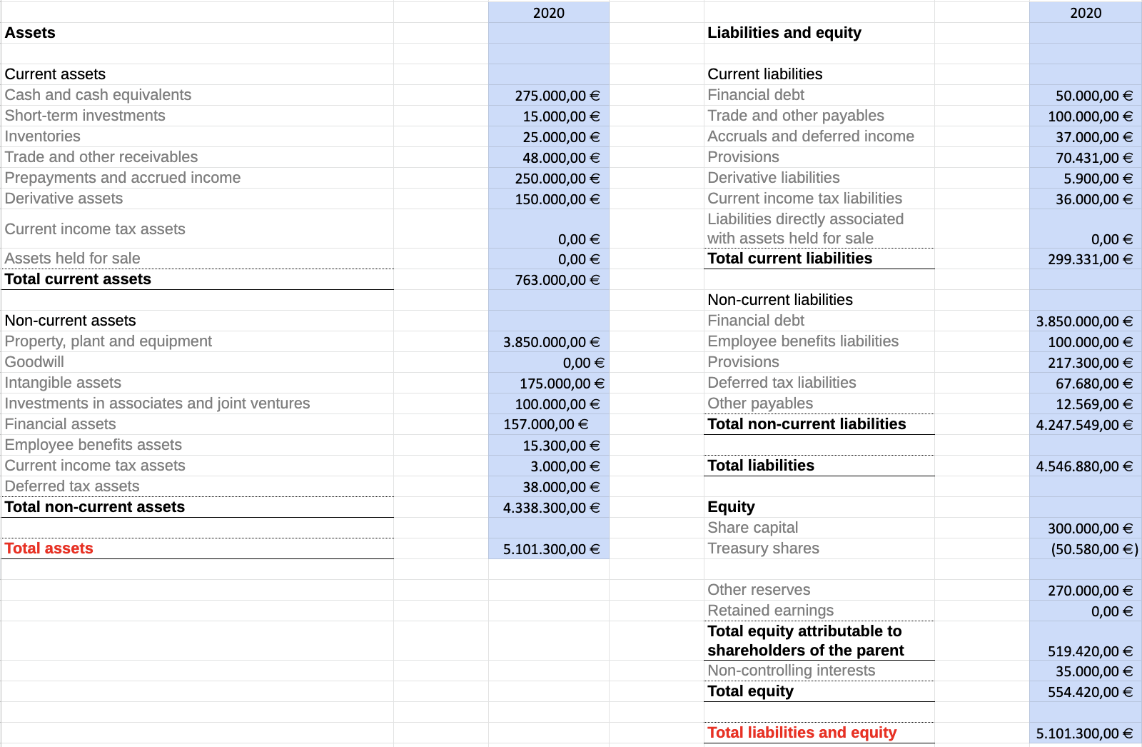

**6.4 Income statement**

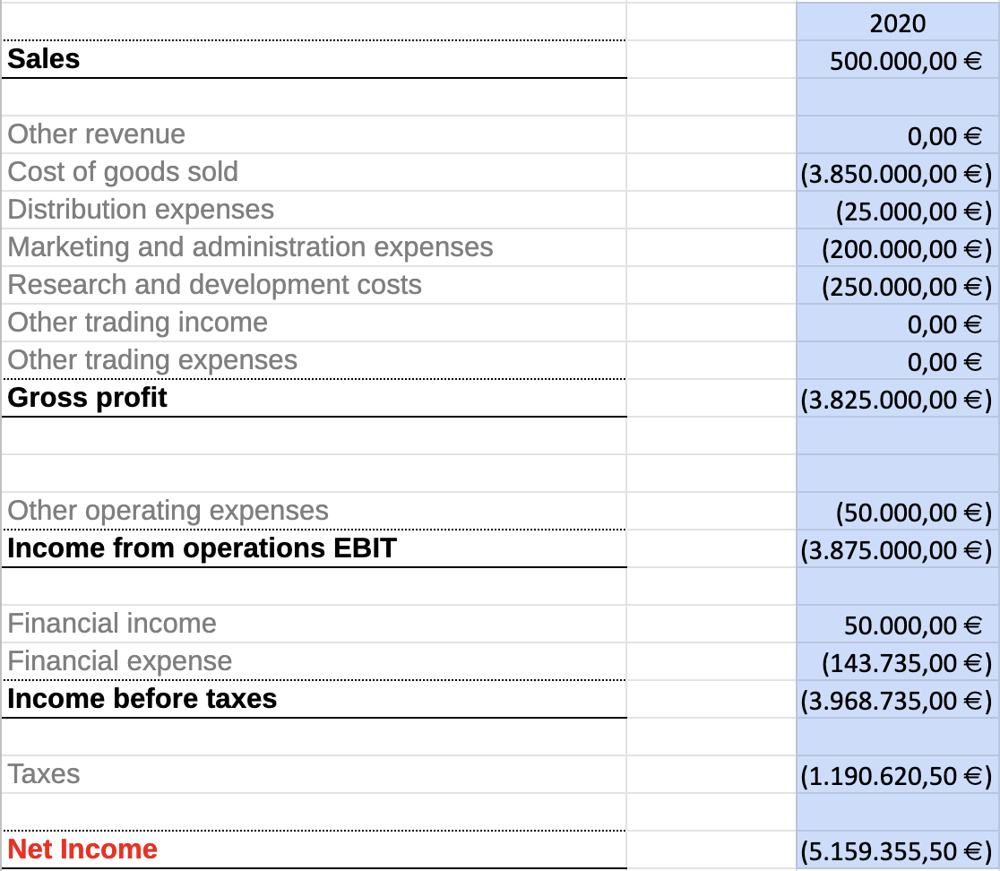

**6.5 Forecast for following years**

The forecast of the cash-flows for the first 5 years of the company:

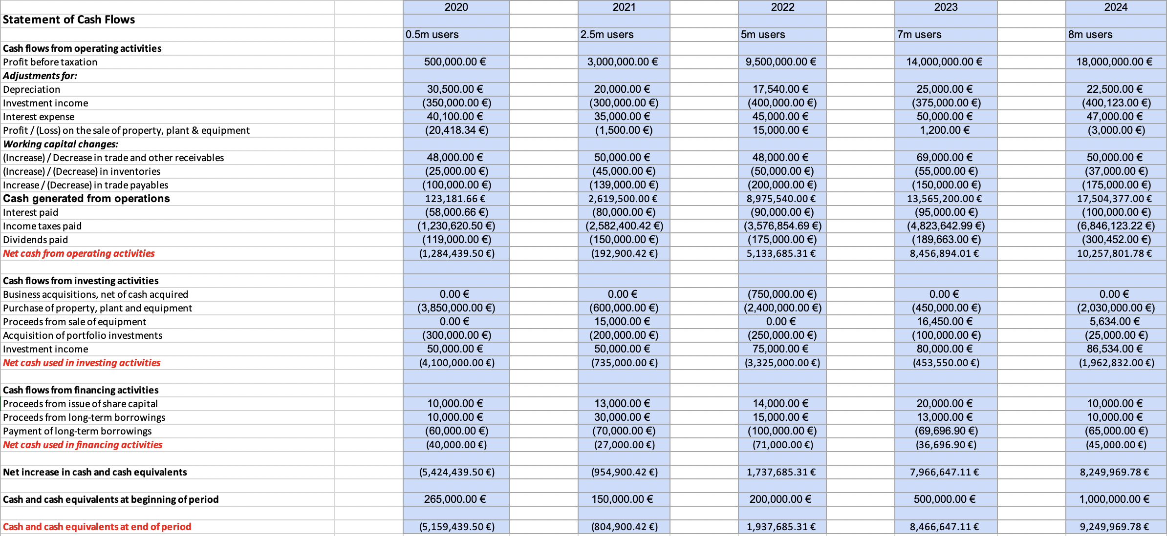

Also the forecast of the future NPV values for the same 5 years, considering a discount rate of 8%, will be:

Year 1= -6.208.086,41 € Year 2= -7.159.055,72 € Year 3= -4.670.658,17 €

Year 4= 7.147.781,68 € Year 5= 21.182.418,45 €

**6.6 Economic & Financial profitability (ROA & ROE)**

The Economic profitability (ROA) and the Financial profitability (ROE) of the company the first year of its incorporation are as follow:

ROA= -0,76=-76% ROE=-9,30=-930%

And lastly the Financial Leverage, the relation between ROA and ROE, is -5,69

**7. Organizational Structure**

**7.1 Company’s structure**

Since one of the most important characteristics of our service is that it grows and expands with users, we believe that innovation within the company must be essential. And for that same reason, we want the organization of our company to allow the flow of new ideas from any of our employees. Although, we have to be able to maintain a sufficiently robust structure, because the image we want to give to the companies that work with us must be of certain stability.

Taking this things into consideration, we think that our company should be shaped as a flatarchy. We plan NexuSpace to be separated into several departments that, although they work independently of each other, they will always have continuous contact with us, the four founders. All the people inside the same department will be at the same level. The outward communication will be through a spokesperson. This position can rotate to give everyone the opportunity to represent their group.

But, although we have previously commented that our company is structured into independent departments, employees belonging to different sections may have to cooperate with each other. If any of our employees have an idea, after presenting the necessary information about their plan, we will allow them to form their own research and development group with the people they deem necessary from each department.

**7.2 Employee distribution**

In the first years of the company, since we do not want to have very high expenses, we will employ a relatively small group of people among whom, the tasks will be distributed. We estimate that the number of employees we will have will be between 80 and 85.

To obtain this number we have considered the distribution of workers among the following departments: ( we will include the different department names and an example of employee distribution).

| Programmers: 9 employees (≈ 11 % total) | Electricians: 5 employees (≈ 6 % total) |
| --- | --- |
| Design: 5 employees (≈ 6 % total) | Customer support: 8 employees (≈ 10 % total) |
| Marketing: 15 employees (≈ 18 % total) | Technical support: 15 employees (≈ 18 % total) |
| Cleaning: 5 employees (≈ 6 % total) | Legal team: 5 employees (≈ 6 % total) |
| Security: 5 employees (≈ 6 % total) | Human Resources: 11 employees (≈ 13 % total) |

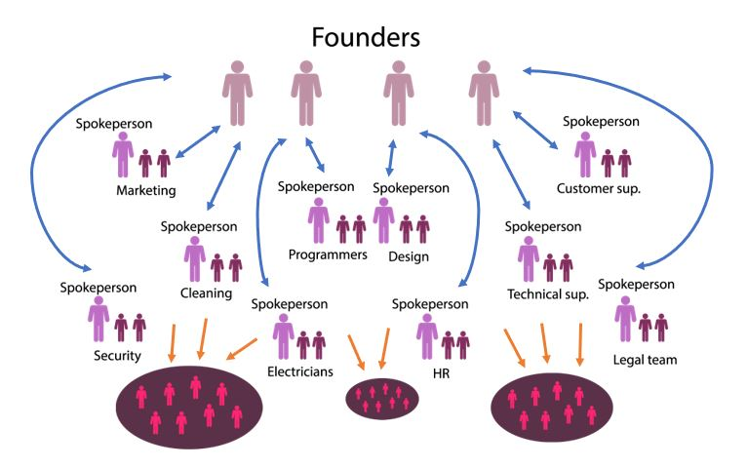

**7.3 Recruiting, selecting and training**

The responsibilities of the human resources department are to look for possible candidates for each position, conduct the relevant interviews and recommend the best candidate for the necessary position. Once the relevant hiring has been made, new employees should be trained so that they can understand how the company works and what their functions will be within it. Our plan is that the training process also serves to integrate the new worker to the department where he/she will belongs.

Regarding the recruitment phase, we would like to offer employment at university fairs to attract young people who share our values. But, we will also look for more experienced profiles to give consistency and add experience to the department.

Finally, regarding the interviews, we will look for people who are interested in innovation, who want to express their ideas and who want to grow and improve as a professional while doing their job.

**7.4 Forecast of the HR needs**

Among the human resources expenses we will consider the wages of the workers (which will vary depending on the department), the expenses for the activities of point 7.3 and the insurances that we will give to employees.

We estimate that over the years the number of employees in our company will grow, so the expected expenses of HR will grow in a very similar way (including also, some increments in the salaries itselves through the years). Although, our company gets to be better known, the expenses for self promotion will be reduced. Within the expenses (included in point 6) we count the possible accidents at work, as well as the periods of maternity / paternity and the vacations for the workers.

Finally, we have to include the economic compensation to the employees derived from the motivational strategies that we will carry out. In the first years, since we will be still developing the organization of the company, we want to create some “improvement campaigns”. In these campaigns any employee can suggest a way to improve their department and the best suggestion will be economically compensated.

An estimation of the salaries, for each charge in the company could be as follows (each quantity is shown as a monthly pay):

| Department | Year 1 | Year 2 | Year 3 | Year 4 | Year 5 |
| --- | --- | --- | --- | --- | --- |
| Cleaning | 1.000,00 € | 1.015,00 € | 1.115,00 € | 1.325,00 € | 1.500,00 € |
| Programers | 2.000,00 € | 2.200,00 € | 2.500,00 € | 3.200,00 € | 3.500,00 € |
| Security | 1.100,00 € | 1.120,00 € | 1.250,00 € | 1.500,00 € | 1.650,00 € |
| Electrical technician | 1.200,00 € | 1.300,00 € | 1.458,00 € | 1.700,00 € | 2.000,00 € |
| Customer attention | 1.200,00 € | 1.250,00 € | 1.325,00 € | 1.550,00 € | 1.900,00 € |
| Marketing | 1.650,00 € | 1.700,00 € | 1.800,00 € | 2.050,00 € | 2.300,00 € |
| Technical support | 1.800,00 € | 1.825,00 € | 1.950,00 € | 2.200,00 € | 2.500,00 € |
| Legal team | 2.500,00 € | 2.500,00 € | 2.600,00 € | 2.750,00 € | 2.900,00 € |
| Design team | 1.800,00 € | 1.850,00 € | 1.975,00 € | 2.150,00 € | 2.400,00 € |
| Human Resources | 2.000,00 € | 2.075,00 € | 2.350,00 € | 2.700,00 € | 3.000,00 |

Laura: Presentacion producto, mercado (putos 2-3)

Alejandro: … Conclusion

Santiago: “This is NexuSpace, prepare yourself” (xD) Introduccion & Putos numeros